Name : KEERTHANA R
Reg No : 411625104031
Department : CSE
Subject : JAVA(OOPS)
Batch : 3
Title : Library Book Borrowing System using Exception Handling in Java

Aim:
To design and implement a Java program for a library book borrowing system using exception handling. The program demonstrates how custom exceptions can be used to handle invalid conditions while borrowing books.

Procedure
Step 1: Creating Custom Exception Class
A custom exception class named BookNotAvailableException was created.
This class extends the Exception class and is used to display error messages when invalid borrowing conditions occur.

Step 2: Reading User Input
The Scanner class was used to read input from the user.
The program asks the user to enter:
• Library name
• Book title
• Number of books available in the library
• Number of books to borrow

Step 3: Validating Borrow Conditions
The program checks several conditions before allowing the borrowing process:
• If the number of books requested is less than or equal to zero
• If the requested books exceed the available books
• If the requested books exceed the maximum borrowing limit of 5
If any of these conditions occur, a BookNotAvailableException is thrown with an appropriate error message.

Step 4: Applying Exception Handling
The try-catch-finally block was used to manage exceptions.
• try block – Contains the main logic for checking conditions and processing the borrowing operation.
• catch block – Catches the custom exception and displays the corresponding error message.
• finally block – Executes a statement indicating that the library transaction is completed.

Step 5: Updating Library Records
If all conditions are valid:
• The borrowed books are subtracted from the available books.
• The program displays the library name, book title, borrowing success message, and remaining books in the library.

Step 6: Testing
The program was tested by:
• Entering valid borrowing numbers
• Requesting more books than available
• Requesting more than the maximum limit
• Entering invalid values such as zero or negative numbers
The appropriate messages were displayed in each case.

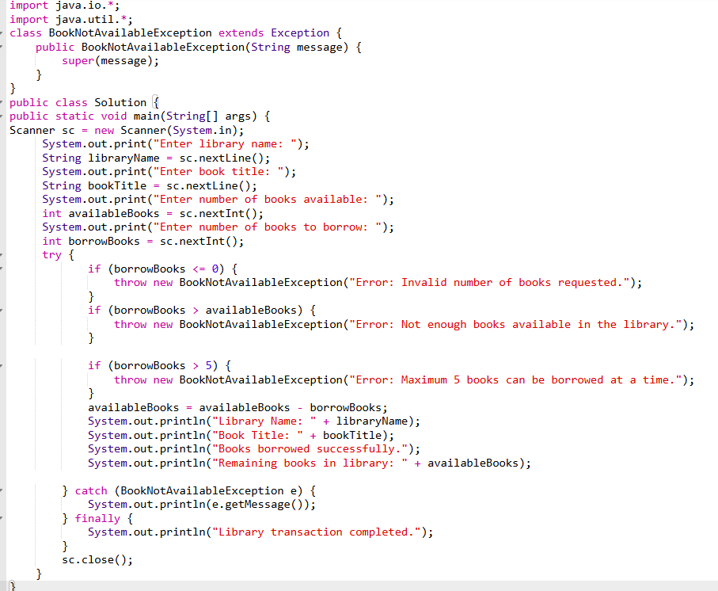

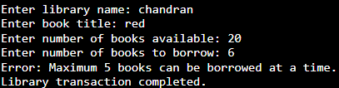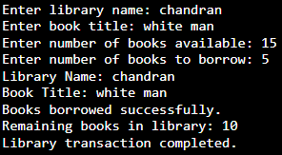
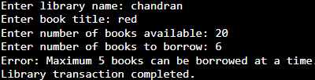
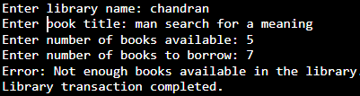
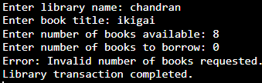
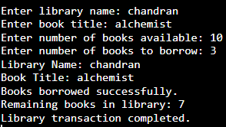

Result:
The program for a library book borrowing system using exception handling was successfully executed. The custom exception effectively handled invalid borrowing conditions, and appropriate messages were displayed to the user. This program clearly demonstrates the use of custom exceptions, try-catch-finally blocks, and error handling in Java.

